ECE 50863 HOMEWORK 1

MALIN PREMATILAKE

QUESTION 1

(a) Time for one packet = Transmission delay + Propagation delay

= (Packet size/Bandwidth) + (RTT/2)

= $\frac{1000 }{\frac{1.5}{8}×{10}^{6}}+25×{10}^{-3}$ s

= 30.3 ms

Time for all packets = 30.3 x (1000 KB/1 KB) = 30.3 s

Time for initial handshake = 2 x RTT = 100ms

Total time = 30.3 + 0.1 = 30.4 s

(b) Time for one packet = Transmission delay + Propagation delay + Wait time

= $\frac{1000 }{\frac{1.5}{8}×{10}^{6}}+25×{10}^{-3}+ 50×{10}^{-3}$ s

= 80.3 ms

Time for all packets = 1000 x 80.3 ms + 2 x 50 ms = 80.4 s

QUESTION 2

(a) RTT >= 2 x Propagation delay

RTT >= 2 x (385x106)/(3x108) = 2.56s

(b) Delay x Bandwidth = 2.56x109 Gb

(c) This is the maximum number of bits that could be sent in a packet

(d) Time for the request (assuming packet is very small) = RTT/2 = 2.56/2 = 1.28 s

Time for the data = Transmission delay + Propagation delay

= (25x10 6/ (1/8)x109) + 1.28 = 1.48 s

QUESTION 3

(i) In circuit switching, only one connection can be serviced. Hence one requires 10% of the time, maximum number of users (assuming this is the same as one connection) is 10

(ii) One user requires 100kbps.

Hence, number of simultaneous users = 1Mbps/100kbps = 1000/100 = 10

QUESTION 4

For collision detection,

(minimum frame size/bandwidth) > 2*Propagation delay

1000/(100 x 106) > 2 x length/(2x108)

1000 > length

Therefore, maximum length of the wire is 1000m

QUESTION 5

(a) After the ith collision, the wait period is between 0 and 2i-1 time units.

This is the first collision. Hence i=1.

Hence, wait period is between 0 and (2-1) -> 0 and 1

1. Hence, possible combinations: <0,0>,<0,1>,<1,0>,<1,1>
2. <0,1>

(b) This is the second collision for both A and B. Hence, i=2.

Hence, wait period is between 0 and 23-1 -> 0 and 3

1. Hence, possible combinations:

<0,0>, <0,1>, <0,2>, <0,3>, <1,0>, <1,1>, <1,2>, <1,3>, <2,0>, <2,1>, <2,2>, <2,3>,

<3,0>, <3,1>, <3,2>, <3,3>

1. <0,1>, <0,2>, <0,3>, <1,2>, <1,3>, <2,3>

QUESTION 6

After applying the spanning tree algorithm, B1 is chosen as the root node.

Hence, ports (links) not chosen are: <A, B2>, <B, B5>, <I, B6>

QUESTION 7

Assumption: The transmissions occur one after another

|  |  |  |  |  |  |  |  |  |  |
| --- | --- | --- | --- | --- | --- | --- | --- | --- | --- |
| Message | B1 | | B2 | | | B3 | | B4 | |
| 1 | 2 | 1 | 2 | 3 | 1 | 2 | 1 | 2 |
| D to C | D |  | D |  |  | D |  | D |  |
| C to D | D |  | D | C |  | D | C | D | C |
| A to C | D | A | D | C | A | D, A | C | D | C |

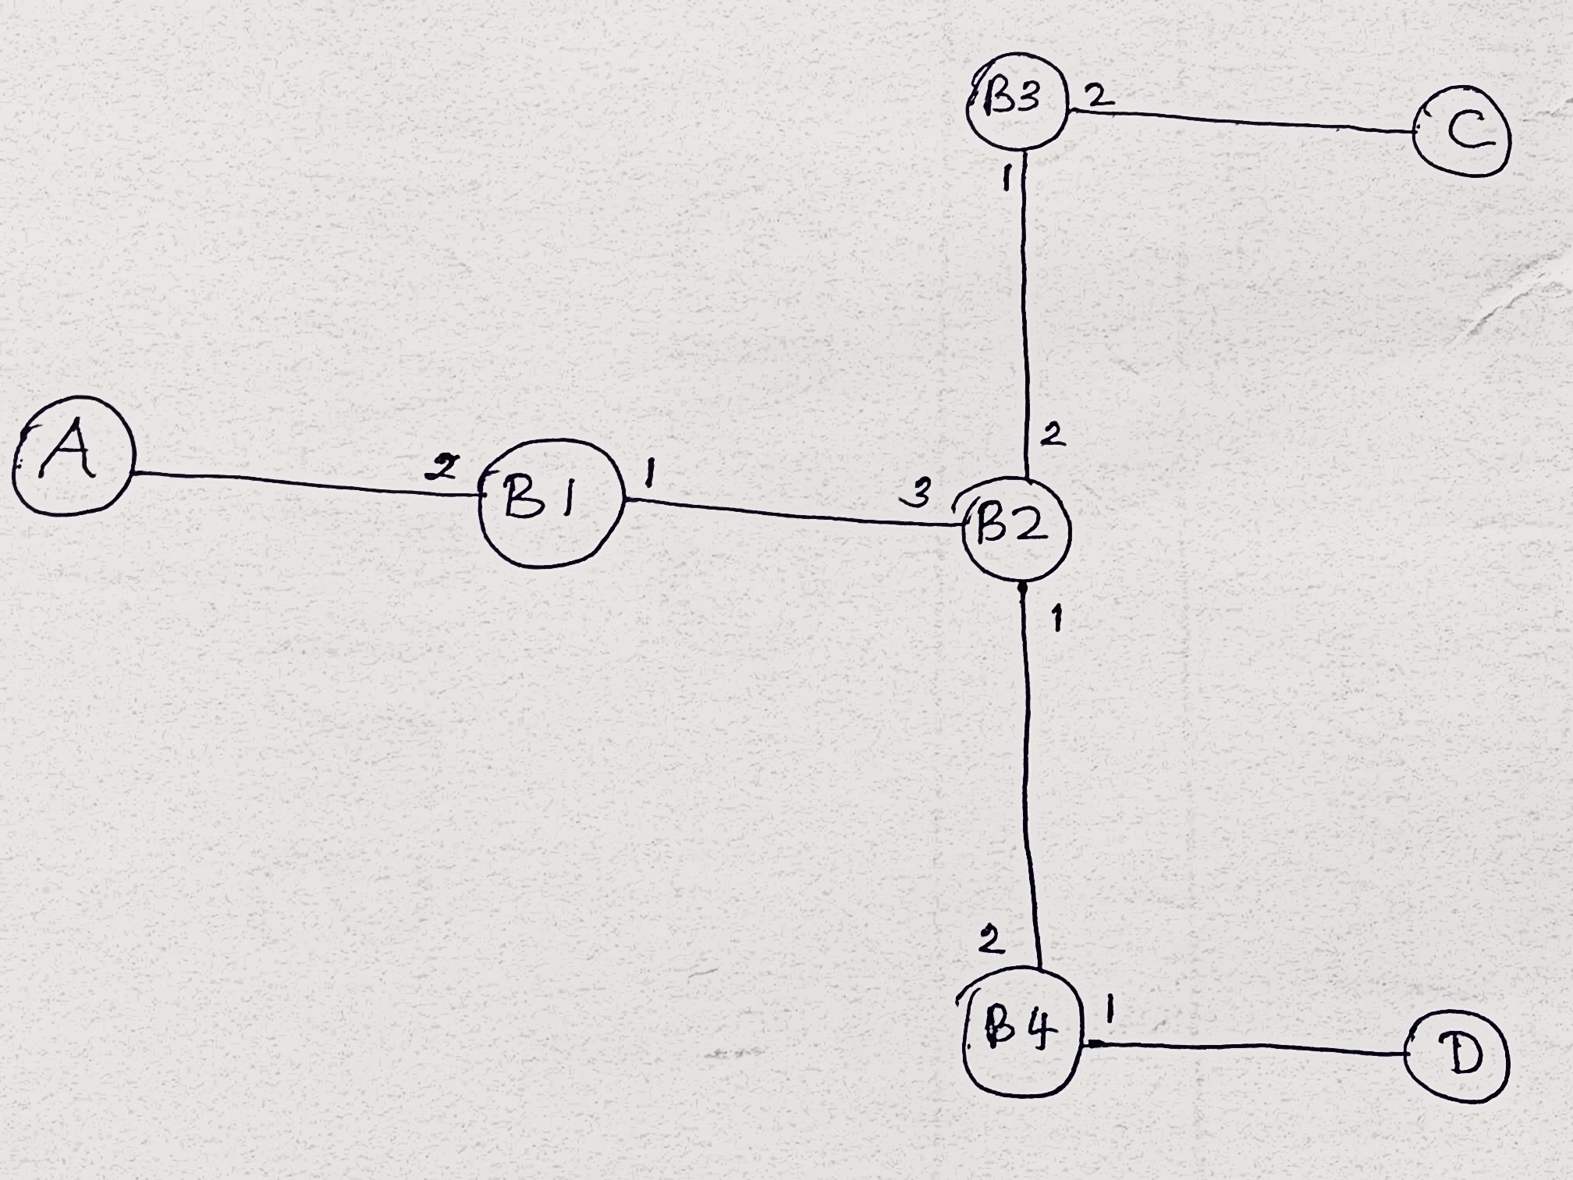

Figure 1: Port numbers